Horizontal supply conductor is a 10m long wire with a diameter of 2mm. It has an average height of 1.6m over the ground plane. Based on arrangements and dimensions of circuit, the students need to conduct following calculations:

− Calculate the impedance of horizontal supply conductor;

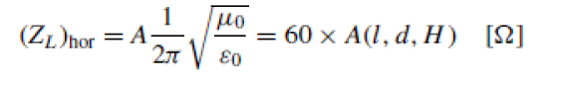

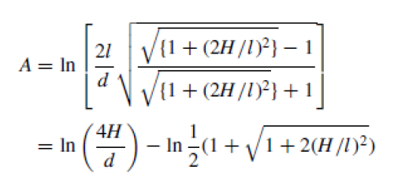

A = 8.3045 Ω

− Calculate the capacitance and inductance of the supply conductor;

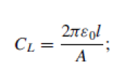

8.85 ×10−12 F⋅m−1

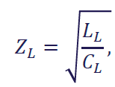

− Calculate the wave propagation velocity 𝑣 in the lead;

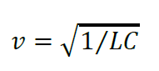

− Calculate the transfer ratio n based on values of the capacitors.

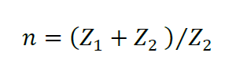

**=**

 Measure 𝑢1(𝑡) and 𝑢2(𝑡) with an oscilloscope, and comment the appearance of the curves. Then import the date files to eg. MATLAB to calculate the response time T.

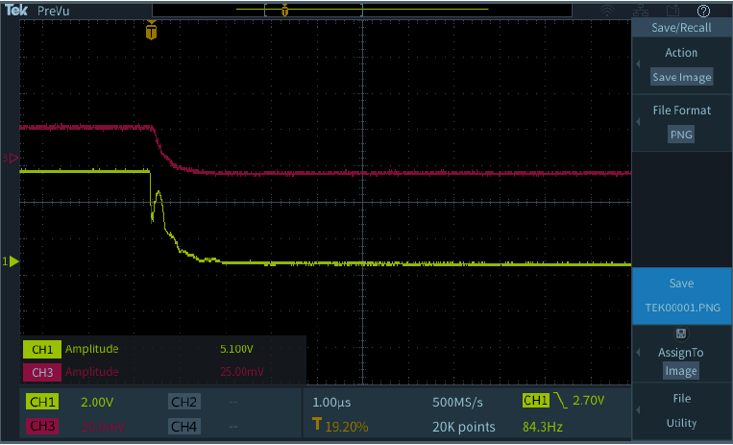

From the scope the input voltage (5V amplitude) is the yellow curve and the voltage after the capacitive voltage divider is the red curve (25mV amplitude). If we compare both curves it can be validated the transfer ratio found previously:

5V /25mV = 200 = n

Moreover, the output voltage does not reach the final value of the input step voltage because of the capacitors of the voltage divider. In this case the value of Rd = 470 which allows to damp the input voltage and that is why in the output voltage there is no overshoot.

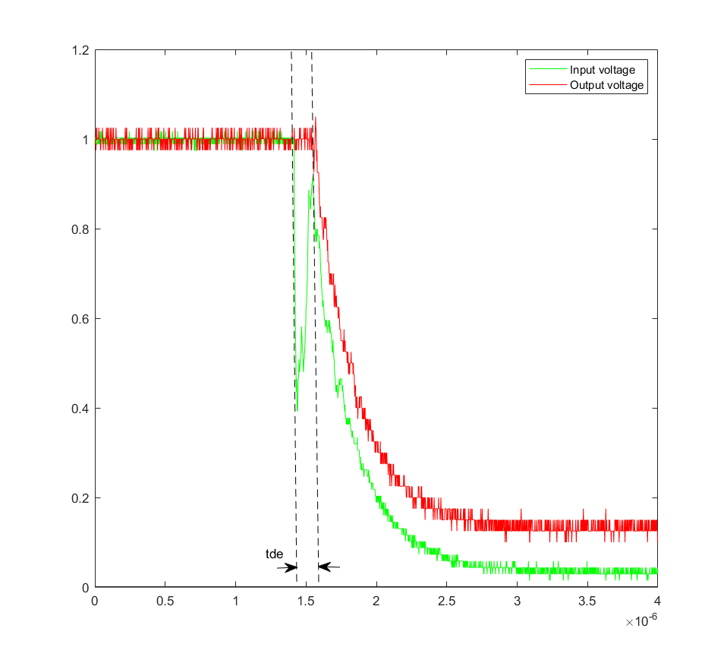

The response time is calculated as stated in the following equations:

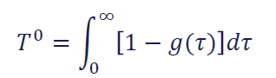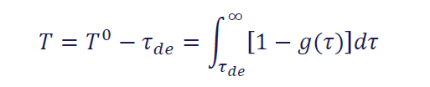

**T = – tde = 211.13**

Where tde is the is the time delay at which the output voltage starts falling from 1 to 0.

 Short circuit 𝑅𝑑 and measure 𝑢1(𝑡) and 𝑢2(𝑡) again. Calculate the response time T in this case.

If the value of Rd is 0 then the system will be undamped and therefore more oscillations will appear in the time response. The next figure reflects these oscillations and even though it seems that the response time in this case is higher than the damped system it is not. This is because when the output voltage gets lower than 0 it is necessary to subtract this time periods as: 𝑇=𝑇1−𝑇2+𝑇3−𝑇4+𝑇5 - ……



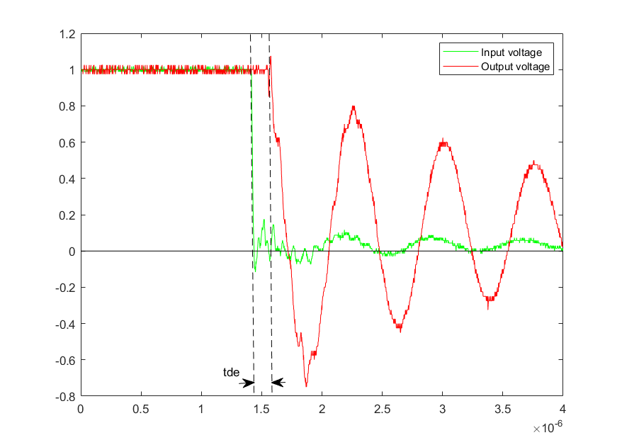

The response time is:

T = T1 -T2 + T3 - T4 + T5 -T6 + T7 – tde = 482.9

 Calculate the impulse voltage peak measuring error Δ𝑉 for the linearly rising impulse voltages with different front steepness 𝑆=2𝑀V/𝜇s, 200 kV/𝜇s and 20 kV/𝜇s.

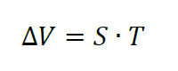

S = 2𝑀V/𝜇s:

T = 211.13 ns 🡪 Δ𝑉 = 422.7 kV

T = 482.9 ns 🡪 Δ𝑉 = 965.8 kV

S= 200 kV/𝜇s

T = 211.13 ns 🡪 Δ𝑉 = 42.27 kV

T = 482.9 ns 🡪 Δ𝑉 = 96.58 kV

S= 20 kV/𝜇s

T = 211.13 ns 🡪 Δ𝑉 = 4.226 kV

T = 482.9 ns 🡪 Δ𝑉 = 9.658 kV